

Model NATO Lviv - 2009

“60th Anniversary of NATO:
Ukraine's Perspective of Common Security”

DATE 25th March – 27th March 2009
LOCATION Lviv, Ukraine


ORGANIZERS Institute of Ukrainian Studies

SHORT DESCRIPTION

Model NATO Lviv-2009 “60th Anniversary of NATO: Ukraine's Perspective of Common Security” is taking part for the first time in Ukraine.

Model NATO - Lviv 2009 gives an opportunity to learn more about NATO and its goal activities. Working in committees, considering different important questions and finding solutions provide profound understanding of what is NATO among youth. It will give a great experience, impression, and knowledge to all participants. So…

Dear colleaques,
It is our pleasure to introduce to you the Model NATO Lviv 2009 “60th Anniversary of NATO: Ukraine's Perspective of Common Security”, which will take place in Lviv on March 25th – March 27th 2009.
THE AIM OF THE PROJECT IS to increase awareness of the youth aged 16 – 22 who is actively involved in the community life, willing to learn about NATO and distribute gained knowledge in their community about NATO, its goals, activities and procedures.
During the project participants will learn about NATO its goal activities and procedures by participation in the simulation of work of NATO’s bodies, attending lectures and seminars; participating in the simulation of meetings of some NATO committees and North Atlantic Council.

PARTICIPANTS. We are inviting 60 young people 16 – 22 who are actively involved in their community life, willing to learn about NATO and distribute gained knowledge in their communities about NATO, its goals, activities and procedures.

15 participants from Lviv;
15 participants from Lviv region;
15 participants from all Ukraine
15 participants from abroad;

All participants will be divided into 4 committees in which they will work according to the topic of each committee. During the simulation of the committee work each participant will represent one of the NATO member states.

COMMITTEES
Committee | Discussion topic
Joint Committee on Proliferation | System PRO in Central European States
Military committee | Russia's Navy based in Crimea
Political Committee | NATO's response to the regional conflicts (Transnistria, Georgia): lessons and consequences of Kosovo and Georgia
Economic Committee | Energy resources security of NATO member states

PROGRAM
Wednesday, 25th of March2009

6:00 – 9:30 Arrival of participants, Check into the hotel and registration
11:00 – Lecture “History, Structure and objectives of NATO”
12:30 – coffee break
13:00 – VTC with NATO HQ, Lecture “Decision Making Process in NATO”
14:30 – Lunch
16:00 - Opening Ceremony (introductory speech of the guests)
16: 45 – Embassy Briefing on “The role of my country in North Atlantic Organization”
18:30 – Welcome Reception
21:30 – City night tour

Thursday, 26th of March2009

7:30 – 8:00 Breakfast
08:30 - Brief Description of the planned activity for the whole day
09:00 – Team Building in each committee
11:00 – Committee Session (each committee according to the topic)
- Joint Committee on Proliferation- System PRO in Central European States;
- Military committee - Russia's Navy based in Crimea;
- Political Committee - NATO's response to the regional conflicts (Transnistria, Georgia): lessons and consequences of Kosovo and Serbia
- Economic Committee - Energy resources security of NATO member states
14:00 – Lunch
15:00 – Committee Session (each committee according to the topic)
- Joint Committee on Proliferation- System PRO in Central European States;
- Military committee - Russia's Navy based in Crimea;
- Political Committee - NATO's response to the regional conflicts (Transnistria, Georgia): lessons and consequences of Kosovo and Serbia
- Economic Committee - Energy resources security of NATO member states
19:30 – Dinner and Party

Friday, 27th of March2009

7:00 – 8:00 Breakfast at the hotel
08:30 - Brief Description of the planned activity for the whole day
09: 30 – meeting of North Atlantic Council
11:00 – Coffee Break
11:15 - meeting of North Atlantic Council
12 :00 – Closing Ceremony,: Honoring Best Speakers of each Committee
12: 30 – Press Conference: “Why NATO Model is important for Ukrainian youth”
13: 30 - lunch
15 : 00 - Check out from the hotel

HOW TO PARTICIPATE :
If you would like to become a delegate for the Model NATO Lviv -2009 please,
- fill in the application form( At the end of the document)
- send your CV
- write essay in English on the topic “60th Anniversary of NATO: Ukraine’s Perspective of Common Security”
The application form, CV and essey should to be sent to info@ius.lviv.ua

Deadline for the application submission is: 15th of March 2009,
but the applications will be process on the first come first served basis.

There is no participation fee.
We cover accommodation and food.
We also cover travel expenses for participants from Ukraine (the cheapest means of transport).
For participants from Abroad we do not cover travel and visa expenses

Application Form

Full Name, Surname as stated in passport
- Pasport data ( for participants who need visa)
- Date of Birth
- Educational Institution, department
- Home address, home and mobile telephone numbers including area code, e-mail
- Choose two of 4 committees you prefer to take part in
- Choose 3 Country from the list of NATO member state which you would like to represent

Belgium Bulgaria Canada Czech Republic Denmark Estonia France Germany Greece Hungary Iceland Italy LatviaLithuania Luxembourg Netherlands Norway Poland Portugal Romania Slovakia Slovenia Spain Turkey United Kingdom United States

We are looking forward to seeing all of you in Ukraine in the beautiful, charming and ancient city of Lviv (West of Ukraine).
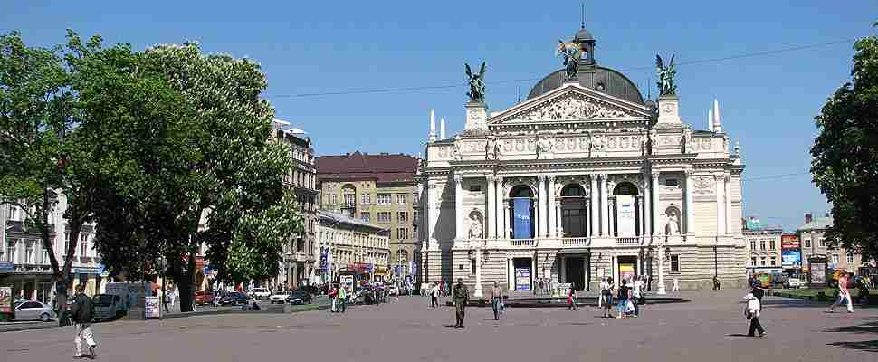
THE CITY OF LVIV

Located in the far western part of Ukraine, a city of more then 800,000 inhabitants and over 750 years old Lviv is an open air museum, embodiment of the Ukrainian culture and European charm, unforgettable panoramas and unique monuments of architecture, old traditions and, surely, flavored coffee in the legendary Lviv coffee houses.
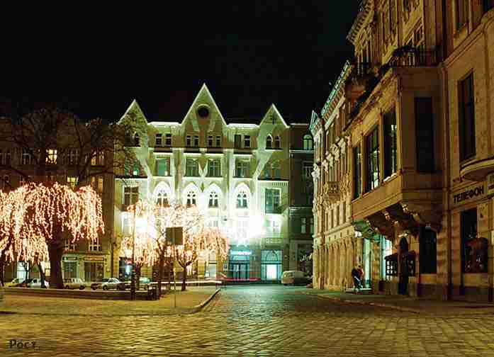
- On December 05, 1998, during the 22nd Session of the World Heritage Committee in Kyoto (Japan), Lviv was included in the UNESCO World Heritage List.
- Lviv celebrated its 750th anniversary in September 2006

The city, just like a harmonious melody, awakens the best sensations in one’s soul. Its old buildings, statues give you the atmosphere of past which is so close and at the same time so far. Its coffee houses give you a felling of comfort and are ready to accept you in any time you like.
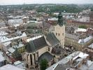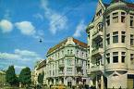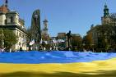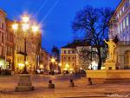

This hospitable city is waiting for all of you on March 25th – March 27th 2009 to participate in the Model NATO Lviv- 2009

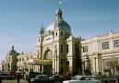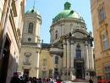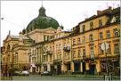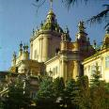
More at http://www.about.lviv.ua/
General Information about your stay in Lviv
1. Accommodation Details:
During your stay in Lviv you will be accommodated at the hotel «Lviv», which is placed in the city center .
2. Visa:
There is no visa entry to Ukraine for all citizens of EU, Norwey, Iceland, Lichtenstein, Switzerland, USA Canada, Japan and most of the post Soviet Countries. We will provide Official Invitation for those who need it.
3. Internet Access:
The hotel is in the city center, there is wi – fi Internet access near by. Also there are lots of internet cafés in the city.
4. Travel & health insurance:
This is very important for you! You are strongly advised to have health insurance, or any similar document.
5. Currency and money:
Ukrainian currency is hryvnia.
6. Clothes:
Official dress code is required.
7. Travell support:
There are an international airoport in Lviv and Kyiv ( capital of Ukraine) if you wish to travel by plane and there are bus and train stations. We will meet you at any of these places in Lviv. If you flight to Kyiv you can catch the night train to Lviv. It costs around 10 Euro. It is recommended that you let us know from which city you are planning to go, and we will tell you the best way to get to Lviv.
If you decide to travel by plain it will be much cheaper to flight to Poland. And catch the bus or the train to Lviv. Note: that you might need visa to Poland !
Fill free to ask all the questions to organizing committee.

There are few websites of travel companies that could be usefull for you:

Ukraine,Lviv:
http://www.aerosvit.ua/eng.html
http://www.flyuia.com/ua/main.html
http://www.expresstorussia.com/russian_train_schedules.html
http://www.donbass.aero/m1/en/index
http://wizzair.com/ ( cheap flight from Kyiv- Lviv- Kyiv, also there are internetional connection with Cologne, Dortmund, London, Cracow, Katowice,Sandefjord Torp )

Via Poland:
http://wizzair.com/
http://www.ryanair.com/site/EN/?culture=GB
http://easyjet.com/en/book/index.asp

If you have any question, please feel free to contact organizing committee info@ius.lviv.ua

